Web Development Course:
Web Development:
Web development is the process of designing and developing websites using technologies like HTML, CSS, and JavaScript to make them functional and interactive.
Web Site Front End Development+ Backend Development +Database
A website is built using three main parts: Front End Development + Back End Development + Database.
Together, these components make the website visible, functional, and capable of storing data.
Front End Development Technologies:
- HTML
- CSS
- JavaScript
Backend Development:
- Node.js
- Java
- Python
- PHP
Database:
- MySQL
- MongoDB
Key Technologies:
- HTML: The standard markup language for creating web pages.
HTML creates the structure of a webpage.
Ex: Heading, Paragraph, Image, Button, Form
- CSS: A language used to describe the presentation of a web page, including layout, colors, and fonts.
CSS is used to design and style the webpage.
Ex: colors, fonts, spacing, layout, alignment
- JavaScript: A programming language used for client-side(Browser) scripting, enabling dynamic and interactive web pages.
JavaScript makes webpages interactive and dynamic.
Ex: button click actions, form validation, popups, sliders, menus

Client-side(user machine) vs Server-side scripting:
Client-side scripting improves user interaction, while server-side scripting handles business logic and database operations.
Client-side:
Runs inside browser
Example: JavaScript
Server-side:
Runs inside server
Example: Node.js / Java

Example: Login page
Step-by-step:
- User enters username
- Frontend sends request
- Backend verifies data
- Database checks records
- Response sent back to user
Career Opportunities:
- Frontend Developer
- Backend Developer
- Full Stack Developer
- UI Developer
- React Developer

Example:
<!DOCTYPE html>
<html>
<head>
<link rel="stylesheet" href="style.css">
</head>
<body>
<h1 style="color:blue">Hello Skillhub</h1>
<button onclick="showmessage()">Click Me</button>
</body>
<script src="script.js"></script>
(Or)
<script>

function showmessage(){
alert("Welcome Everyone")
}
</script>

</html>
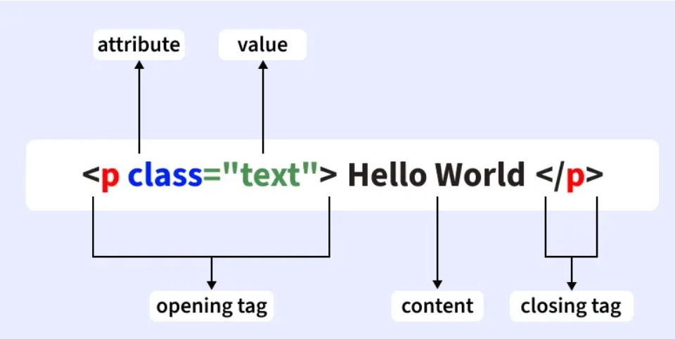
- The <!DOCTYPE html> declaration defines that this document is an HTML5 document
- The <html> element is the root element of an HTML page
- The <head> element contains meta information about the HTML page

- The <title> element specifies a title for the HTML page (which is shown in the browser's title bar or in the page's tab)
- The <body> element defines the document's body, and is a container for all the visible contents, such as headings, paragraphs, images, hyperlinks, tables, lists, etc.
- The <h1> element defines a large heading
- The <p> element defines a paragraph
- <> angle brackets
If you used click as a function name and it’s not working, the most common reason is that click is already a built-in browser event/function name in JavaScript. So it can cause conflicts or unexpected behavior. ⚠️
<button onclick="click()">Click Me</button>

<script>
function click(){
alert("Hello");
}
</script>
click() conflicts with the browser’s default click event method, so it may not run properly.

- Points Need to consider as web developer:
- Web application need to be responsive
- Web app should have good visibility & performance along with user friendly experience
2-April-2026:
HTML:
- HTML structure deeply
- Basic tags usage
- Page layout creation
- Forms introduction

  - <!DOCTYPE html>
<html>
<head>
<title>Page Title</title>
</head>

<body>

Content

</body>
</html>

HtmlRoot Element
HeadMeta information
TittleBrowser Tab name
BodyVisible Content
2.HTML Headings & Paragraphs:
<h1>Main Heading</h1>
<h2>Sub Heading</h2>
<p>This is paragraph text</p>
3. Text Formatting Tags:
<b>Bold</b>
<i>Italic</i>
<u>Underline</u>
<strong>Important</strong>
4. Lists:c
Ordered List: upper-roman,lower-roman,upper-alpha,lower-alpha,decimal
<ol style=”list-style-type:decimal”>
<li>HTML</li>
<li>CSS</li>
<li>JavaScript</li>
</ol>
Unordered List: disc,circle,square,none
<ul>
<li>Apple</li>
<li>Mango</li>
<li>Orange</li>
</ul>
5.Images in HTML:
<img src="image.jpg" width="200">
Attribute | Purpose
src | image location
width | image size
height | image size
alt | accessibility text

6.Links (Anchor Tag):Navigation between pages and to open external pages
<a href="https://google.com">
Visit Google
</a>
7.Tables:
<table border="1">
<tr>
<th>Name</th>
<th>Course</th>
</tr>

<tr>
<td>Satya</td>
<td>Web Development</td>
</tr>

</table>
- tr → row
- th → heading cell
- td → data cell
8.Forms: forms used to collect group of data & it used for validation and send data server
Note: check without form required
<form>
<label for=”text”>Name: </label>
<input type="text" id=”text”>
<br><br>

<label for=”pass”>Password:</label>
<input type="pass" >
<br><br>
<input type="submit">
</form>
for attribute improves user experience
Ex:
<button style="background-color:#ffffff;color:blue;border-radius:10px">click Me</button>
<span>:It is used to create inline content for block level elements
<p style="color:red">Hello <span style="color:blue">Satya</span> </p>
4-April-26:
image iframe and input types and semantic void elements and attributes and comments inline and block line elements
Block vs Inline elements:
Block level: Each element appears on a new line
<h1>Heading</h1>
<p>This is paragraph</p>
<div>This is div</div>
Inline elements: Inline elements do NOT start on a new line. They take only required width.
<span>,<a>,<b>,<i>,<img>
Attributes provide additional information about an element
<p id=”123” class=”333”>This is paragraph</p> //id and class are attributes

<h1> to <h6>, each displaying the heading in a different font size.
Comments:
<!-- This is a single-line comment -->
<!--
This is a multi-line comment
spanning multiple lines
-->
<iframe src="URL" title="description"></iframe>
iframes are used for various purposes like:
- Embedding Multimedia: Easily integrate videos, audio, or animations from platforms like YouTube, etc.
- Including Maps: Embed maps from services like Google Maps directly into your site.
- Loading Forms and Widgets: Incorporate forms or widgets from other sources without writing complex code.
<img src=”bike.jpg” />
Void elements : Not have closing tag
Ex: <br /> <img />,<hr />,<meta/>,<link / >,<input />,<meta />
These tags do action and not contain content
If element has content → closing tag required
If element has no content → no closing tag
<div> is a generic container used to group elements together.

Semantic tags: Semantic tags are HTML tags that describe the meaning of the content they contain.
<header>
<nav>
<section>
<article>
<footer>
07-04-26:
<input> element: The <input> element is used to create form fields where users can enter data
- We use <input> to collect user information such as:
- Name
- Email
- Phone number
- Password
- Date
- Gender selection
- Upload files
- Submit form
- <input> void element and does not have a closing tag

Ex:
Used to enter short text <input type="text">
Used to enter hidden characters/Password <input type=”password”>
Used to enter email address <input type="email">
Used to enter numbers<input type="number">
Used to select date<input type="date">
Used to select one option <input type="radio">
Used to select multiple options <input type="checkbox">
Used to submit form data <input type="submit">
Placeholder attribute:
Displays hint text inside input box <input placeholder="Enter Name">
Sets default value <input value="Satya">
<label for="name">Name</label>
<input id="name" placeholder="Enter Name">
- for="name" connects label
- id="name" connects input
Ex:
<form>
<label for="username">Username</label>
<input id="username" placeholder="Enter Username">
<br><br>
<label for="password">Password</label>
<input type="password" placeholder="Enter Password">
<br><br>
<input type="submit">
</form>

Key points to remember :
- <input> is used inside forms
- It is a void element
- It does not need closing tag
- type attribute defines input behavior
- label improves accessibility
- placeholder shows hint text

Void Elements:
Void elements are HTML elements that do not have a closing tag and cannot contain content inside them
correct(<input />) wrong(<input> </input>)
ex:
<input> Input element
<br> Line break element
<hr> Horizontal line element
<img> Image element
<meta> Provides page information
<link> Connects CSS file
<area>
<base>
<col>
<embed>
<source>
<track>
<wbr>
<div> stands for division.
It is mainly used to organize content, structure layout, and apply CSS or JavaScript to grouped elements.

